CSC 352 / 452: Database Programming
assignment #2 (60 Points)

CSC 352/452-501:
- Due on Thursday, 9/20/2012 at midnight. Any homework that is late will lose 50% of the points for each day that it is late. No homework will be accepted more than two days after its due date.

CSC 352/452-510:
- Due on Friday, 9/21/2012 at midnight. Late homework will not be accepted or graded.

If you modified the DEPARTMENT and EMPLOYEE tables created in Assignment #1, you need to truncate/delete and re-populate them.
To avoid complicating issues, you can assume that the user always enters input from keyboard that consists only of the digits 0 through 9 and Enter.

You cannot use hard-coded values in your programs.
The EXCEPTION Section is NOT allowed in your programs.
Explicit cursors are NOT allowed in your programs.

1) (CSC 352 - 15 points | CSC 452 – 10 points)

Based on the EMPLOYEE table created in Assignment #1, write a PL/SQL anonymous block that accepts an employee ID from the user input and displays the employee name and job.

Example:

ACCEPT p_1 PROMPT 'Please enter the Employee ID:'
DECLARE
-- Your statements

BEGIN
-- Your statements
END;

Please test your program.
The output of your program must match the following:

Case 1) (CSC 352 - 6 points | CSC 452 – 4 points)
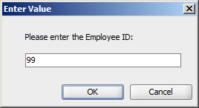

Output:
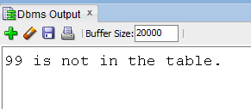

Case 2) (CSC 352 - 9 points | CSC 452 – 6 points)

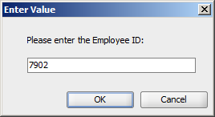

Output:
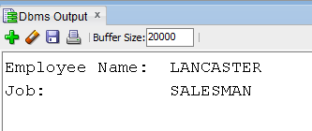

2) (CSC 352 - 25 points | CSC 452 – 20 points)

Based on the DEPARTMENT and EMPLOYEE tables created in Assignment #1, write a PL/SQL anonymous block that accepts an employee ID from the user input and displays the name, total pay (salary + commission), manager name, and department name for the employee along with the highest total pay (salary + commission) in the department.

Hint: joins may not be necessary in your queries. Do not try to use ONE SELECT statement to get the results.

Please test your program.
The output of your program must match the following:

Case 1) (5 points)

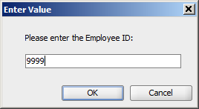

Output:
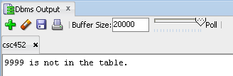

Case 2) (CSC 352 - 10 points | CSC 452 – 8 points)

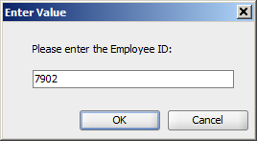

Output:

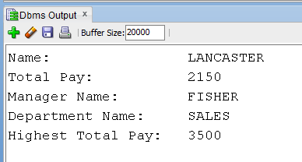

Case 3) (CSC 352 - 10 points | CSC 452 – 7 points)

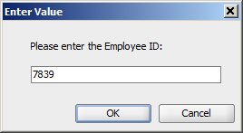

Output:

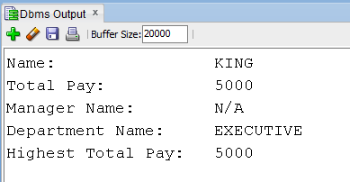

3) (CSC 352 - 20 points | CSC 452 – 15 points)

In mathematics, the Fibonacci numbers are the numbers in the following integer sequence:

0, 1, 1, 2, 3, 5, 8, 13, 21, 34, 55, 89, 144, …

In mathematical terms, the sequence F_{n} of Fibonacci numbers is defined by the recurrence relation

F_{n} = F_{n-1} + F_{n-2}, (n >= 2),

with seed values

F₀ = 0, and F₁ = 1.

Write a PL/SQL anonymous block that accepts an integer n (30 ≤ n ≤ 70) from the user input and displays F_{n-3,} F_{n,} and F_{n+3}.

Please test your program.
The output of your program must match the following:

Case 1) (1 point)

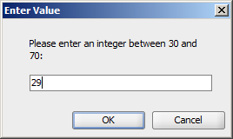

Output:

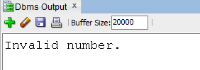

Case 2) (1 point)

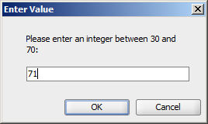

Output:

Case 3) (CSC 352 - 15 points | CSC 452 – 10 points)

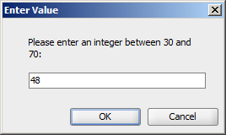

Output:

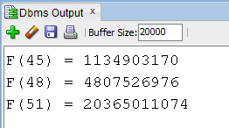

Case 4) (3 points)
The user enters 30 or 70.
……

4) (CSC 452 only – 15 points)

In a bug tracking database, there is a table called BUGS. The table has several columns: BUG_ID, REPORTED_DATE, DESCRIPTION, PRIORITY, ASSIGNED_TO, CLOSED_DATE, and NOTE.

a) Create and populate the BUGS table.

CREATE TABLE bugs
(
BUG_ID NUMBER PRIMARY KEY,
REPORTED_DATE DATE NOT NULL,
DESCRIPTION VARCHAR2(20),
PRIORITY NUMBER(2),
ASSIGNED_TO VARCHAR2(10),
CLOSED_DATE DATE,
NOTE VARCHAR2(20)
);

INSERT INTO BUGS VALUES (1230, '25-APR-12', NULL, 3, 'Team 3', '28-APR-12', NULL);
INSERT INTO BUGS VALUES (1231, '29-APR-12', NULL, 1, 'Team 1', '29-APR-12', NULL);
INSERT INTO BUGS VALUES (1232, '03-MAY-12', NULL, 1, 'Team 1', '03-MAY-12', NULL);
INSERT INTO BUGS VALUES (1233, '03-MAY-12', NULL, 1, 'Team 3', '08-MAY-12', NULL);
INSERT INTO BUGS VALUES (1234, '04-MAY-12', NULL, 2, 'Team 5', '15-MAY-12', NULL);
INSERT INTO BUGS VALUES (1235, '04-MAY-12', NULL, 2, 'Team 1', NULL, NULL);
INSERT INTO BUGS VALUES (1236, '05-MAY-12', NULL, 1, 'Team 2', '06-MAY-12', NULL);
INSERT INTO BUGS VALUES (1237, '05-MAY-12', NULL, 3, 'Team 3', '10-MAY-12', NULL);
INSERT INTO BUGS VALUES (1238, '09-MAY-12', NULL, 4, 'Team 5', '16-MAY-12', NULL);
INSERT INTO BUGS VALUES (1239, '09-MAY-12', NULL, 5, 'Team 6', NULL, NULL);
INSERT INTO BUGS VALUES (1240, '12-MAY-12', NULL, 5, 'Team 2', '30-MAY-12', NULL);
INSERT INTO BUGS VALUES (1241, '12-MAY-12', NULL, 1, 'Team 1', '12-MAY-12', NULL);
INSERT INTO BUGS VALUES (1242, '13-MAY-12', NULL, 4, 'Team 4', '20-MAY-12', NULL);
INSERT INTO BUGS VALUES (1243, '15-MAY-12', NULL, 4, 'Team 3', '01-AUG-12', NULL);
INSERT INTO BUGS VALUES (1244, '15-MAY-12', NULL, 2, 'Team 4', '20-MAY-12', NULL);
INSERT INTO BUGS VALUES (1245, '20-MAY-12', NULL, 2, 'Team 4', '20-MAY-12', NULL);
INSERT INTO BUGS VALUES (1246, '22-MAY-12', NULL, 2, 'Team 4', '23-MAY-12', NULL);
INSERT INTO BUGS VALUES (1247, '25-MAY-12', NULL, 2, 'Team 1', '29-MAY-12', NULL);
INSERT INTO BUGS VALUES (1248, '30-MAY-12', NULL, 1, 'Team 1', '01-JUN-12', NULL);
INSERT INTO BUGS VALUES (1249, '05-JUN-12', NULL, 1, 'Team 2', '07-JUN-12', NULL);
COMMIT;

“Open Bugs” - A bug is considered open on a given day if (1) its “REPORTED_DATE” is on or before that day, and (2) its “CLOSED_DATE” is on or after that day (or is unknown). For example, we have 2 open bugs on 5/3/2012.

b) (15 points)
Write a PL/SQL anonymous block that generates a report to show the number of open bugs from 5/1/2012 through 5/31/2012. Assume that there were no open bugs on 4/30/2012.

Hint:
If your PL/SQL block has more than 20 lines of code, you may need to simplify your code.
The following WHILE statement may help you.

……
WHILE v_date <= v_end_date LOOP
……
v_date := v_date + 1;
END LOOP;
……

The output of your program must match the following:

Date Number of Open Bugs
01-MAY-12 0
02-MAY-12 0
03-MAY-12 2
04-MAY-12 3
05-MAY-12 5
06-MAY-12 5
07-MAY-12 4
08-MAY-12 4
09-MAY-12 5
10-MAY-12 5
11-MAY-12 4
12-MAY-12 6
13-MAY-12 6
14-MAY-12 6
15-MAY-12 8
16-MAY-12 7
17-MAY-12 6
18-MAY-12 6
19-MAY-12 6
20-MAY-12 7
21-MAY-12 4
22-MAY-12 5
23-MAY-12 5
24-MAY-12 4
25-MAY-12 5
26-MAY-12 5
27-MAY-12 5
28-MAY-12 5
29-MAY-12 5
30-MAY-12 5
31-MAY-12 4

Please submit a text file containing all the source codes to COL before or on due date.

